30/06/21
THM 415: Finance
Midterm Exam
Note to the students:
- Calculations to reach your answers shall be thoroughly shown. Otherwise, questions will NOT be graded.
- You can use a calculator throughout the exam.

- Briefly explain the “Double Taxation” issue confronted by corporations? Does this issue apply to all investors? Explain. (2 Points)

- Costa Hotel had recorded the following income statement accounts sorted in alphabetical order:
Cost of Goods Sold | $518,472
Interest Expenses | $101,101
Operating Expenses | $324,896
Sales | $2,025,639

In addition, since Costa Hotel owns 34 % shares of Diego Company, it is entitled to $ 501,903 of dividends income from that very company. Moreover, Costa hotel’s board of directors decided to distribute $ 314,314 as dividends to their shareholders.
The following table reveals Income Tax Rates for Corporate Income for 2020 fiscal year:

Taxable Income | Marginal Tax Rate
$ 0 – $ 50,000 | 15%
$ 50,001 - $ 75,000 | 17%
$ 75,001 - $ 125,000 | 19%
$ 125,001 - $ 300,000 | 21%
$ 300,001 - $ 500,000 | 23%
$ 500,001 - $ 780,000 | 25%
Over $ 780,000 | 27%

Lastly, the following table shows dividend income exclusion to avoid double taxation at corporate level.
Ownership Interest | Dividend Exclusion
Less than 10 % | 15%
10 % to 30 % | 30%
30 % to 50 % | 45%
50 % to 75 % | 65%
75 % to 92 % | 88%
More than 92 % | 100%

a) Construct Costa Hotel Income Statement for the year ended December 31st, 2020. (2 Points)
Moreover, the following is Costa Hotel’s comparative balance sheet as of December 31st, 2019 and December 31st, 2020:
- Construct Costa Hotel Statement of Cash Flow for the year ended December 31st, 2020. (3 Points)
- Calculate the Quality of Earnings. Interpret your result. (1 Point)
- Calculate the Capital Acquisition Ratio. Interpret your result. (1 Point)
- Based on the income statement prepared in part a), comparative balance sheet and cash flow statement prepared in part b), analyze the financial situation of Costa Hotel for the fiscal year 2020. (3 Points)

- Suppose you would like to triple your investment. For this purpose, you deposited in a bank $ 17,321.07 to be compounded monthly at an interest rate of 4.55 %. Calculate the period (in years) needed to reach your objective? (1 Point)
- After examining the various interest rates opportunities, you find that you can borrow from finance company at 17.04 % compounded monthly, from bank A at 17.30 % compounded quarterly or from Bank B at 16.92 % compounded continuously. By showing all necessary calculations, which alternative is the most attractive? Why? (1 Point)

- Mandzukic wanted to buy a home that costs $ 250,000. He took a 10-year mortgage loan with semi-annual payments at an annual rate of 2.36 %.
a) How much will Mandzukic pay each period? (1 Point)
b) Fill in the amortization schedule. (3 Points)
c) Suppose that exactly after 4 years, mortgage interest rates fell to 2.04 %. If Mandzukic has the chance to refinance his loan at that very interest, how much would he pay (on a semi-annual basis) for the remaining 6 years of the loan? (2 Points)
d) If such a refinance opportunity is associated with paying a prepayment penalty fee to the bank of $ 1,300, would Mndzukic refinance his loan? Why? Why not? (2 Points)

- Upon evaluation of the distribution of returns of Benatia company, the following possible rate of returns for the upcoming period as long as their probability of occurrence are estimated:

Probability of Occurrence | Rate of Return on Investment
8% | -10.63%
12% | -7.14%
14% | -2.59%
16% | 1.34%
18% | 4.89%
19% | 9.17%
13% | 11.69%

a) Calculate the Expected Rate of Return of Benatia Company stock. (1 Point)
b) What is the risk of the investment in Benatia Company stock as measured using the standard deviation of possible future rates of return? (2 Points)

- Demogaj bought some stocks of Vida Company worth of 565,000 Euros 8 years ago. Following is the beginning value of Vida’ bought stocks 8 years ago as well as the values at the end of each year up until today (the end of year 8):
Year | Annual Rate of Return | Stock Value (Euros)
0 |  | 565,000.00
1 | -2.53% | 550,705.50
2 | -1.25% | 543,821.68
3 | 3.14% | 560,897.68
4 | 5.87% | 593,822.38
5 | 3.99% | 617,515.89
6 | 4.04% | 642,463.53
7 | -1.02% | 635,910.40
8 | 5.05% | 668,023.88

a) What will be the annual rate of return that Demogaj expects to earn next year, if he plans to continue holding Vida Company stocks? (1 Point)
b) What annual rate of return that Demogaj expects over a five-year horizon from holding Vida Company stocks? (1 Point)

- The following monthly observations of BJK, FB, GS and TS stocks along with BIST 100 Index rate of returns are depicted as follows:
Observation | Date | BIST 100 Index | BJK | FB | GS | TS
1 | Apr-20 | -2.35% | -1.52% | 3.30% | -4.09% | 2.44%
2 | May-20 | -5.16% | 5.25% | -6.21% | -3.80% | -3.15%
3 | Jun-20 | -7.52% | 6.33% | -9.55% | -4.62% | 5.01%
4 | Jul-20 | -2.63% | 2.47% | -5.32% | -5.02% | -3.40%
5 | Aug-20 | 4.42% | 4.78% | -2.26% | -3.95% | 4.02%
6 | Sep-20 | 5.45% | -6.25% | -2.84% | -1.63% | -8.42%
7 | Oct-20 | 3.85% | -3.54% | 7.35% | 3.22% | -6.41%
8 | Nov-20 | 7.15% | 5.18% | 2.25% | -1.25% | 6.24%
9 | Dec-20 | 2.23% | 4.71% | -6.32% | 8.65% | -2.94%
10 | Jan-21 | 7.44% | 9.56% | 4.83% | 7.52% | 9.52%
11 | Feb-21 | 5.03% | 5.26% | 7.89% | 6.32% | 6.34%
12 | Mar-21 | -2.11% | 8.99% | 1.93% | 9.77% | 10.13%
13 | Apr-21 | 4.25% | 3.66% | 6.84% | 5.22% | 9.78%
14 | May-21 | 0.44% | 9.03% | 1.03% | 1.09% | 3.04%

- According to the above historical rate of returns data, what are the betas of BJK, FB, GS, and TS stocks? (3 Points)
- If you decided to have a portfolio that include 25 % of BJK stocks, 15 % of FB stocks, 20 % of GS stocks, and 40 % of TS stocks, what would be the beta of the portfolio? (0.50 Points)
- If the risk free rate is 4.78 %, and the market risk premium is 2.53 %, what would be the required rate of return on your portfolio in part b)? (0.50 Points)
- If the expected return on your portfolio (as shown in part b) is 5.14 %. Would you invest in said portfolio? Why? Why not? (2 Points)
GOOD LUCK!

THM 415 Finance
Formulae Sheet Paper
Midterm Exam
Chapter 3
Profits = Revenues – Expenses
Earnings Per Share (EPS) = Net Income / Number of Outstanding Common Shares
Dividends Per Share (DPS) = Total Dividends Paid / Number of Outstanding Common Shares
Gross Profit Margin = Gross Profits / Net Sales
Operating Profit Margin = Net Operating Income / Net Sales
Net Profit Margin = Net Profits / Net Sales
Total Assets = Total Liabilities + Total Shareholders’ Equity
Net Working Capital = Current Assets – Current Liabilities
Change in Cash Flow (Year_{t}) = Ending cash Balance (Year_{t}) – Ending Cash Bance (Year_{t-1})
Quality of Earnings = Cash Flow From Operations / Net Income
Capital Acquisitions Ratio = Cash Flow From Operations / Cash Paid For Capital Expenditures

Chapter 5
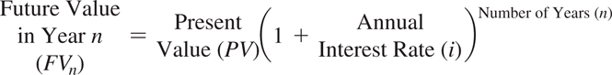
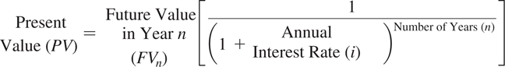
Approximation Formula: Nper = 72/interest rate
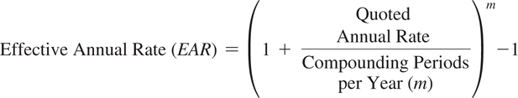
EAR = (e ^{quoted rate} ) – 1 (Continuous Compounding)

Chapter 6
Ordinary Annuity
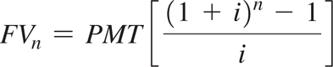
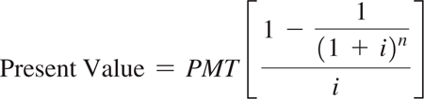
Annuity Due
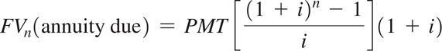
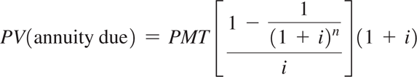
Perpetuity
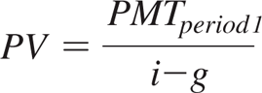

Chapter 7
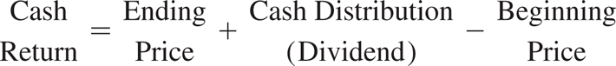
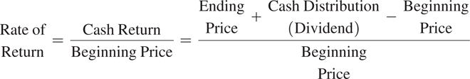
Variance
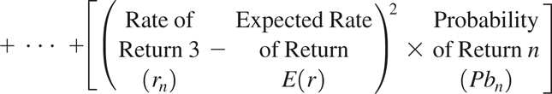

Chapter 8
Portfolio Standard Deviation (with 2 assets)

